|  |
| --- |
| Photo displaying partial image of two pie charts on a canvas-textured page |
| PO3_DGW  Customer System Requirements Specifications Document |
|  |

# **Status Table**

|  |  |
| --- | --- |
| PO3_DGW_CYRS | |
| *Version* | V0.3 |
| *Status* | Draft |
| *Author* | * Bassem Ezzat (Architect) * Mohammed Elsayed (Developer) |
| *Last updated date* | 30/1/2020 |
| *Reviewer* |  |

# **Table of history**

|  |  |  |  |
| --- | --- | --- | --- |
| *Version* | *Author(s)* | *Date* | *Changes* |
| 0.0 | - Bassem Ezzat  - Mohammed Elsayed | January 24, 2020 | Creation of CYRS document |
| 0.1 | - Bassem Ezzat  - Mohammed Elsayed  - Mariam El-Shakafi | January 25, 2020 | Added further details to requirements based on SIQ answers |
| 0.2 | - Mariam El-Shakafi | January 30, 2020 | Updated FUNC_ PO3_DGW_CYRS_07 |
| 0.3 | - Mohammed Elsayed | January 30, 2020 | Review points covered |

Contents

Status Table 1

Table of history 1

1. Introduction 3

1.1. Purpose 3

1.2. Document Abbreviation 3

1.3. Intended audience and reading suggestions 3

1.4. Project Scope 3

1.5. References 3

2. Overall Description 4

2.1. Product features 4

2.2. Operation environment 5

2.3. Design and Implementation constraints 5

3. System Features 6

3.1. Functional requirements 6

3.1.1. FUNC_PO3_DGW_CYRS_01_V01 6

3.1.2. FUNC_PO3_DGW_CYRS_02_V01 6

3.1.3. FUNC_PO3_DGW_CYRS_03_V01 6

3.1.4. FUNC_PO3_DGW_CYRS_04_V01 6

3.1.5. FUNC_PO3_DGW_CYRS_05_V01 7

3.1.6. FUNC_PO3_DGW_CYRS_06_V01 7

3.1.7. FUNC_PO3_DGW_CYRS_07_V02 7

3.1.8. FUNC_PO3_DGW_CYRS_08_V01 7

3.1.9. FUNC_PO3_DGW_CYRS_09_V01 7

# **Introduction**

* 1. Purpose

This document aims to clarify the CRS document and list a customer requirement specification to design a digital watch.

* 1. Document Abbreviation

|  |  |
| --- | --- |
| CYRS | Customer System Requirement Specifications |
| CRS | Customer Requirement Specifications |
| ERD | Entery relational digram |
| SIQ | Software interactive questionnaire |
| FUNC | Functional button |
| INC | Increment button |
| DEC | Decrement |

* 1. Intended audience and reading suggestions

This project is a prototype for a digital watch, and it is applicable to be a commercial product. This has been implemented under the guidance of ITI’s trainers.

* 1. Project Scope

The purpose of this project is to create modern stunning digital watch.

* 1. References

Not available yet

1. Overall Description
   1. Product features

The major feature of the digital watch as listed below.

* Display time with 12 AM/PM format.
* Alarm to set according to user input.
* Stopwatch (Start, Stop).
* Three buttons to control the system:
  + MODE
  + FUNC1
  + FUNC2

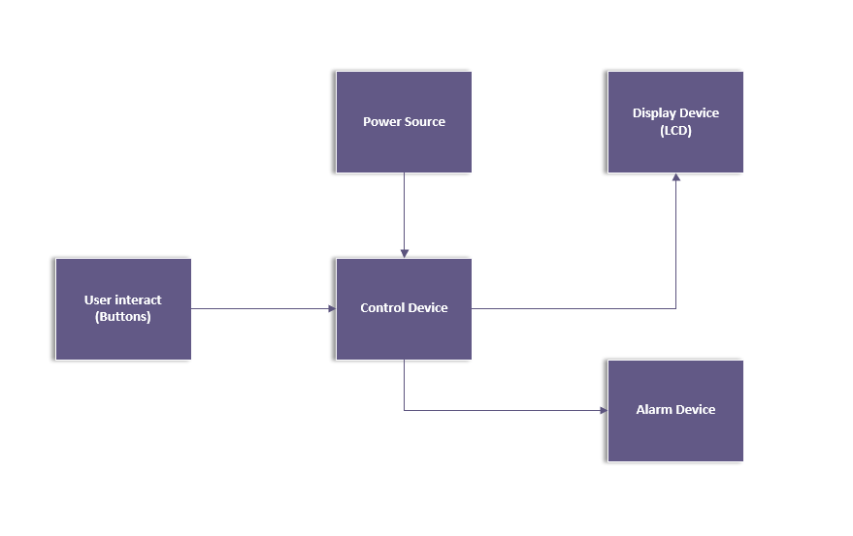

Figure 1. Overview block diagram

* 1. Operation environment

Operating environments for the digital watch are houses, offices, shops, and hotels.

* 1. Design and Implementation constraints
* Software layer design
* Hardware components selection

1. System Features
   1. Functional requirements
      1. FUNC_PO3_DGW_CYRS_01_V01

Display Time Mode:

* The software shall enter Display Time mode when current mode is Stopwatch mode and MODE button is pressed, or when system is powered-up.
* The software shall display the time in HH: MM: SS AM/PM format.
  + 1. FUNC_PO3_DGW_CYRS_02_V01

Adjust Time:

* To adjust the time (Minutes), press FUNC1 button once, so the minutes start blinking to indicate that it can be modified using FUNC2 button.
* To adjust the time (Hours), press FUNC1 button twice, so the hours start blinking to indicate that it can be modified using FUNC2 button.
* To adjust the time (AM/PM), press FUNC1 button a third time, so the format starts blinking to indicate that it can be modified using FUNC2 button.
* To apply adjustments, press FUNC1 button for a fourth time.
  + 1. FUNC_PO3_DGW_CYRS_03_V01

Alarm Mode:

* The software shall enter Alarm mode when current mode is Display Time mode and MODE button is pressed.
* The software shall display the time in HH:MM:SS AM/PM format until Alarm time is reached.
  + 1. FUNC_PO3_DGW_CYRS_04_V01

Set Alarm:

* To adjust alarm time (Minutes), press FUNC1 button once, so the minutes start blinking to indicate that it can be modified using FUNC2 button.
* To adjust alarm time (Hours), press FUNC1 button twice, so the hours start blinking to indicate that it can be modified using FUNC2 button.
* To adjust alarm time (AM/PM), press FUNC1 button a third time, so the format starts blinking to indicate that it can be modified using FUNC2 button.
* To set alarm, press FUNC1 button for a fourth time.
  + 1. FUNC_PO3_DGW_CYRS_05_V01

Buzzer:

* The software shall trigger a buzzer with notification when alarm time is reached in Alarm mode.
* The software shall stop buzzer when FUNC2 button is pressed.
  + 1. FUNC_PO3_DGW_CYRS_06_V01

Stopwatch Mode:

* The software shall enter Stopwatch mode when current mode is Alarm mode and MODE button is pressed.
* The software shall display 00:00:00.
  + 1. FUNC_PO3_DGW_CYRS_07_V02

Start Counting:

The software shall start counting when FUNC1 button is pressed in Stopwatch mode initial state, or paused state.

* + 1. FUNC_PO3_DGW_CYRS_08_V01

Stop Counting:

The software shall stop counting when FUNC1 button is pressed in Stopwatch mode running state.

* + 1. FUNC_PO3_DGW_CYRS_09_V01

Reset Counting:

The software shall reset counter to 00:00:00 when FUNC2 button is pressed in Stopwatch mode.

|  |  |
| --- | --- |
| **CYRS REQUIREMENT** | **CRS REQUIREMENT** |
| FUNC_ PO3_DGW_CYRS_01_V01 | Display the time with 12 AM/PM format |
| FUNC_ PO3_DGW_CYRS_02_V01 | User can adjust time using buttons |
| FUNC_ PO3_DGW_CYRS_04_V01 | Alarm to be set as per the input |
| FUNC_ PO3_DGW_CYRS_05_V01 | When alarm time is reached, a buzzer with notification is triggered |
| FUNC_ PO3_DGW_CYRS_07_V01  FUNC_ PO3_DGW_CYRS_08_V01  FUNC_ PO3_DGW_CYRS_09_V01 | Stopwatch with “start, stop, and Reset” |
| FUNC_ PO3_DGW_CYRS_06_V01 | Reset all digits once entering stopwatch mode |
| FUNC_ PO3_DGW_CYRS_01_V01  FUNC_ PO3_DGW_CYRS_03_V01  FUNC_ PO3_DGW_CYRS_06_V01 | User can control digital watch modes using one button |